**DAILY ONLINE ACTIVITIES SUMMARY**

|  |  |  |  |  |  |  |  |  |
| --- | --- | --- | --- | --- | --- | --- | --- | --- |
| **Date:** | **25-06-2020** | | | | | **Name:** | **Shiza Amreen.J** | |
| **Sem & Sec** | **4th Sem B Sec** | | | | | **USN:** | **4AL18CS078** | |
| **Online Test Summary** | | | | | | | | |
| **Subject** | | **--** | | | | | | |
| **Max. Marks** | | **--** | | **Score** | | | **--** | |
| **Certification Course Summary** | | | | | | | | |
| **Course** | **Introduction to R** | | | | | | | |
| **Certificate Provider** | | | **GreatLearning** | | **Duration** | | | **3 Hours** |
| **Coding Challenges** | | | | | | | | |
| **Problem Statement:** [**Write a C Program to reverse the rows in a 2d Array**](https://github.com/orgs/alvas-education-foundation/teams/2nd-year/discussions/136) | | | | | | | | |
| **Status: Completed** | | | | | | | | |
| **Uploaded the report in Github** | | | | | **Yes** | | | |
| **If yes Repository name** | | | | | **Lockdown_coding**  <https://github.com/ShizaAmreen/Lockdown_coding> | | | |
| **Uploaded the report in slack** | | | | | **Yes** | | | |

Certification Course Details:

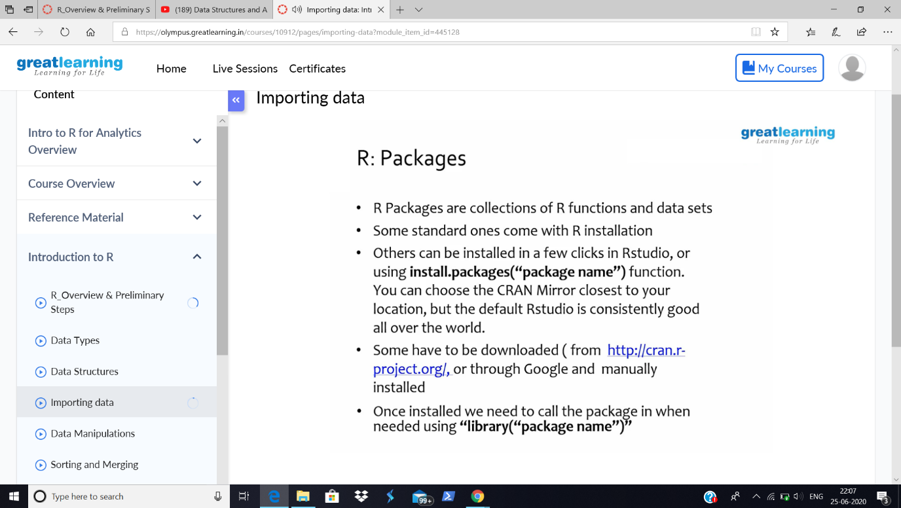

Today In the course, I have learnt about the Importing data, in Introduction to R.

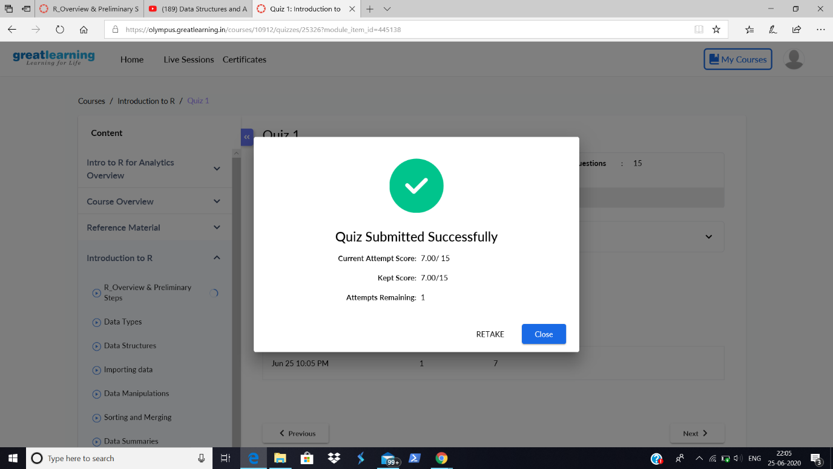

Then I attended a Quiz and got 7 out of 15, which is eligible for getting a certificate at the end of the course.

Coding Challenges Details:

|  |
| --- |
| **Problem Statement:** [**Write a C Program to reverse the rows in a 2d Array**](https://github.com/orgs/alvas-education-foundation/teams/2nd-year/discussions/136) |

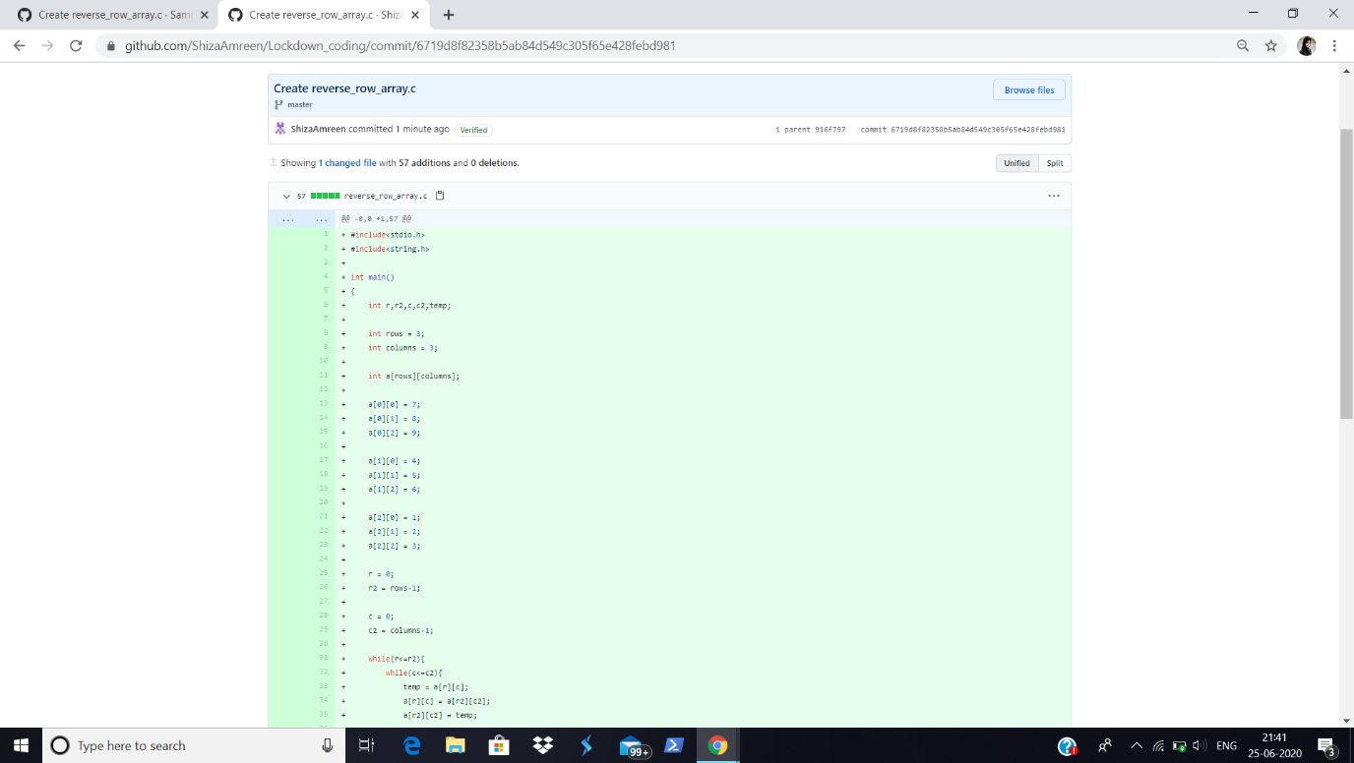

**I have written the code for given problem statement and uploaded it in my github repository, Lockdown_coding.**

<https://github.com/ShizaAmreen/Lockdown_coding/commit/6719d8f82358b5ab84d549c305f65e428febd981>